
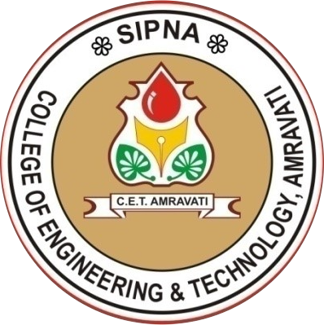


Project Report
ON
“Enhancing Hospital Efficiency with AI-Driven Automation
and Blockchain-Backed Data Management”
IS SUBMITTED TO
SANT GADGE BABA AMRAVATI UNIVERSITY
IN THE PARTIAL FULFILLMENT OF THE DEGREE OF

BACHELORS OF ENGINEERING
IN
COMPUTER SCIENCE AND ENGINEERING
BY

Manish Prakashrao Dhaye Mandar Gajanan Chatur
Prachi Prashant Ghatole Anushka Prakashrao Tayade
Pravesh Chandrashekhar Mhaiskar

GUIDED BY
Prof. Neha Gopal Rathi

DEPARTMENT OF COMPUTER SCIENCE AND ENGINEERING
(ACCREDITED BY NBA)

SIPNA COLLEGE OF ENGINEERING AND TECHNOLOGY, AMRAVATI
(AN ISO 9001:2015 CERTIFIED INSTITUTE & NAAC ACCREDITED)

SANT GADGE BABA AMRAVATI UNIVERSITY, AMRAVATI
2024-2025

